**JavaScript Tutorial**

**Using JavaScript to create structures in Minecraft**

This tutorial gives the basics of the setup needed to start JavaScript programming and what you will need to get started. The student should use the following link as a reference at all times, mentors will also provide guidance.

<https://github.com/walterhiggins/ScriptCraft/blob/master/docs/YoungPersonsGuideToProgrammingMinecraft.md>

Short URL <http://goo.gl/qocSS>

**Step 1**

Install craftbukkit and add the Scriptcraft plugin to the plugins directory. Note the version of Craftbukkit installed will need to match the version of Minecraft you are using. You may also need to install Java on your machine.

**Step 2**

You can tell the hacked Minecraft server how you would like it to run, in order to do this you will need to understand *server.properties* (there's a Wiki) but particularly have the terrain FLAT with monsters and animals set to 'false'. The goal is to populate landscape using Javascript, not to use regular building methods.

**Step 3**

 Understand how to draw shapes from the command line prism, box, cylinder

***box0( block, width, height, depth )*** - creates an empty box (with the insides hollowed out - perfect for

dwellings.

***cylinder( block, radius, height )*** - creates cylinders, perfect for Chimneys.

***cylinder0( block, radius, height )*** - creates empty cylinders - perfect for Towers.

***prism( block, width, depth )*** - creates a Prism - good for roofs.

***prism0( block, width, depth )*** - creates an empty prism.

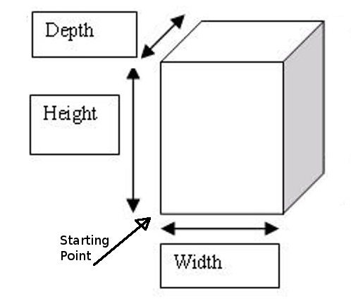

**Step 4**

Understand the drone and how to move the drone (drawing object) after placing a shape. Up() left() right() etc

***up( numberOfBlocks )*** - moves the Drone Up. For example: up() will move the Drone 1 block up. You can tell it how many blocks to move if you want it to move more than one block.

***down( numberOfBlocks )*** - moves the Drone Down.

***Left( numberOfBlocks )*** - moves the Drone Left.

***right( numberOfBlocs )*** - moves the Drone Right.

***fwd( numberOfBlocs )*** - moves the Drone Forward (away from the player).

***back( numberOfBlocs )*** - moves the Drone Back (towards the player)

***turn( numberOfTurns )*** - Turns the Drone Clock-wise (right). For example: turn() will make the Drone turn right 90 degrees. turn(2) will make the Drone turn twice so that it is facing in the opposite direction.

**Step 5**

Build a basic house from the command line by chaining the above shapes and moves.

**Step 6**

Write a function to put in the js-plugin dir to build a basic house :

*function house() { box0(5,x,y,z).up(y).prism0(4,x,z) }*

* *Typing “/js house()” at the command line should build a house*

**Step 7**

Use a loop to build a row of houses.

**Step 8**

Alter the function to take a parameter in and build that many houses.

* e.g. /js house(6) should build 6 houses